**Oral Communication is also Important for STEM and Other Disciplines**

**Committee on Communicating Chemistry in Informal Settings; Board on Chemical Sciences and Technology; Division on Earth and Life Studies; Board on Science Education; Division of Behavioral and Social Sciences and Education; National Academies of Sciences, Engineering, and Medicine (2016). Effective Chemistry Communication in Informal Environments (2016). National Academies Press**

<http://www.nap.edu/catalog/21790/effective-chemistry-communication-in-informal-environments?utm_source=NAP+Newsletter&utm_campaign=0b98a24e61-NAP_mail_new_2016_08_23&utm_medium=email&utm_term=0_96101de015-0b98a24e61-102209993&goal=0_96101de015-0b98a24e61-102209993&mc_cid=0b98a24e61&mc_eid=269c44ae59>

Copyright © National Academy of Sciences. All rights reserved.

Effective Chemistry Communication in Informal Environments

Preface

The committee’s report seeks to enhance the effectiveness of public communication by

chemists at activities that foster engagement and learning outside the classroom setting.

We build on two trends: One is the interest shown by many chemists in sharing

their knowledge and experience with the public through activities such as National Chemistry

Week, science festivals, museum exhibits or events, science cafés, and online media. The

second is the growing research on science communication, informal learning, and chemistry

education. Much of that research has been synthesized in previous National Research Council

reports, including Learning Science in Informal Environments, Discipline-Based Education

Research, and How People Learn, as well as two Sackler Colloquia on The Science of Science Communication and the Chemical Sciences Roundtable’s Chemistry in Primetime and Online. For

the first time, the experiences of these professional communities and the research bases that

support their work have been integrated for the development of practical tools.

Chemistry plays critical roles in our daily lives, community issues, national policy, and

global events. That everyday relevance presents opportunities for interaction with members

of the public who may not be familiar with chemistry or chemical concepts. Evidence-based

communication and engagement activities offer the potential to address the situation. For

students, informal learning experiences can stimulate greater interest in chemistry, complementing

and enhancing the subject as presented within the limitations of the classroom. For

adults, such experiences may help them become more sophisticated about chemistry and its

ubiquitous role in the world around us.

For the chemistry community, we hope that this report will provide insights for thinking

about communication and engagement. It offers guidance based on evidence-based practices

for strengthening the effectiveness of activities, such as placing greater focus on the needs and

interests of the participants, both in planning and implementation.

For informal learning professionals and science communicators, we hope the report will

provide insight from key research findings in the chemical education literature that may

be transferable to addressing members of the public and may suggest directions for future

research. In addition, this report may encourage more chemists and chemistry-related professsionals to partner with science centers and similar organizations to develop and implement

engaging chemistry experiences for children and for adults. Such collaborative efforts could

be significantly enhanced by support from chemistry-based professional organizations and

corporations.

Although this report focuses specifically on chemistry, the communication strategies

could be applied more generally and serve as a model for other disciplines. We hope that

professionals in those disciplines will recognize the value of applying effective practices of

informal learning and science communication, and of partnering with organizations experienced

in engaging with the public.

**National Science Foundation. Award Abstract #0632804 , Technically Speaking**

<http://nsf.gov/awardsearch/showAward?AWD_ID=0632804>

Mathematical Sciences (21)  
  
This project is developing innovative curricular resources to improve the oral communication skills of undergraduate mathematics students. The materials support the learning of effective communication skills for delivering technical ideas to both math-oriented and general audiences. The centerpiece of the project is the creation of a series of instructional video vignettes, to be offered free of charge on the web, that provide a completely new approach to introducing the art of mathematical communication to undergraduates. Based on a compare-and-contrast pedagogical design, the instruction delivered on the website contains multiple vignettes juxtaposing effective and poor oral communication examples. To actively engage the student audience, a diverse group of undergraduate students play various roles in the vignettes. In addition to the video vignettes, the project is developing a companion DVD that contains high resolution copies of the video vignettes, as well as an instructive video by a nationally recognized mathematician and speaker, describing the finer points of delivering an effective talk that are not conducive to the vignette format. The DVD also contains several articles describing various techniques used by STEM instructors to incorporate oral communication into their programs. For evaluation purposes, student presentations delivered before and after the video instruction are being assessed by external reviewers.

--

**Lorelei A. Ortiz, Michelle Region-Sebest and Catherine MacDermott (2016). Employer Perceptions of Oral Communication Competencies Most Valued in New Hires as a Factor in Company Success. Business and Professional Communication Quarterly, 1–14.**

<http://bcq.sagepub.com/content/early/2016/03/10/2329490615624108.full.pdf?ijkey=gCTmPG5DrDasQmD&keytype=finite>

**Abstract**

This article presents findings of a 2014 survey of 72 U.S. employers asking: Which

oral communication skills are most utilized daily by new hires? Which oral skills are

most important to company success? The study utilized Qualtrics to administer a

mixed-methods, 12-question survey to employers of various sizes and across various industries. Findings show that employers rank (a) proper grammar use, (b) team communication, (c) ability to engage in conversation, (d) meeting participation, and (e) ability to speak well using the telephone as the most valued oral competencies for new hires as a factor in company success.

**Introduction**

A quick glance at any job description will likely yield an interesting result: Effective

oral communication skills are usually noted as a key competency desired by the

employer. Most new hires believe they have the necessary communication skills to do

their job, starting on day one. After all, they completed a business communication

course and likely had a speech or business speaking course, possibly an internship, in

addition to countless projects that required speaking. And, if they succeeded in getting

hired, they clearly did well enough in an interview to be offered a job. The healthy

confidence that new hires have in their communication skills is documented in current

research. According to a 2013 Harris-Chegg Foundation poll of 2,001 U.S. college

students entering the job market and 1,000 hiring managers, nearly 80% of students

say they are “very” or “completely” prepared to meet employer demands when it

comes to communication and related skills such as organization (p. 3).

What happens, however, once new hires become part of an organization and have

to leverage their academic and internship learning against the daily communication

exigencies of their new position? This is where the current skills gap becomes evident.

According to Harris-Chegg Foundation (2013), while 80% of college students believe

they are job-ready, only 54% of hiring managers who interviewed recent graduates

would agree. Harris-Chegg Foundation statistics underscore that the greatest discon-

nect is in students’ ability to communicate with bosses and clients—70% of students

scored themselves as effective in this area; only 44% of recruiters agreed (pp. 3-6).

Similarly, a 2013 Lumina-Gallup survey of 628 business leaders in the United States

found that only 11% of the 628 business leaders surveyed strongly agreed that college

graduates have the necessary competencies to succeed in the workplace. Interestingly,

Lumina-Gallup also found that employers rank applied skills such as communication

and knowledge in the field almost equally at 79% and 84%, respectively, as main fac-

tors when hiring (Lumina Foundation & Gallup, 2014, pp. 25-29). Evident from these

numbers is the need for new hires to obtain the skill set that employers desire and to

do so before entering the workforce. As it relates to communication, employers seek

graduates who can connect across audiences and have a broad range for delivering

communication in various capacities. Employers also want graduates who can add

value to the organization and its overall success. Thus, the contributions that new hires

make to the workplace are not viewed as isolated or lacking connectivity to the com-

pany’s overall performance but, rather, are integral to positive outcomes for an organi-

zation. To that end, this article examines the findings of a 2014 survey of 72 employers

in the United States who were asked to describe the oral communication competencies

most utilized by new hires in their organizations and identify which are most important

to their company’s success. An additional objective of the survey was to identify where

gaps exist between the needed oral communication skills of new hires as identified by

employers and the actual skills new hires possess when they graduate and enter the

workforce.

**Margaret Andrews (2015). What Do Employers Want? June 30, 2015 - 5:30pm** <https://www.insidehighered.com/blogs/stratedgy/what-do-employers-want>

I teach courses and executive programs in leadership and management and, as part of my introduction to the class, explain to participants why what they are there to learn is vitally important: these skills are among the most important keys to lifelong career success. Regardless of the country, industry or job they work in, leadership, the ability to work well on a team, and communication skills – among the package known as ‘the soft skills’ – are what will make the crucial difference in their career.

While some colleges, universities, and business schools screen for these soft skills through admissions essays, recommendations, and interviews, we need to go further in developing these skills. In most business schools throughout the world, the emphasis is on the ‘hard skills’ of economics, accounting and finance, rather than the soft skills.  At the same time, many business schools use teams in a wide variety of courses, yet few teach much about how teams really work (e.g., beyond [forming, storming, norming, and performing](http://en.wikipedia.org/wiki/Tuckman%27s_stages_of_group_development)) or how to ‘unstick’ a stuck team – important skills for much of the work our graduates will do over the course of their career.

I’m not alone in thinking this, either. Several recent studies with employers also point to leadership and other ‘soft’ skills as in very high demand for graduates – and in short supply.

**Bloomberg Research**

On the premise that business schools should be producing graduates who have the abilities companies need most, Bloomberg set out to find which skills employers most covet in business school graduates – and which of these skills are hardest for them to find. Recruiters, of which 1320 of them from more than 600 companies responded, picked the five qualities that are most important to them in hiring MBAs, as well as the five that are hardest to find, from this list of 14:

1. Ability to work collaboratively
2. Adaptability
3. Analytic thinking
4. Communication skills
5. Creative problem-solving
6. Decision making
7. Entrepreneurship
8. Global mindset
9. Industry-related work experience
10. Initiative/risk-taking
11. Leadership skills
12. Motivation/drive
13. Quantitative skills
14. Strategic thinking

The most desired and hardest to find skills in today’s MBA market? [Communication, leadership, problem solving, and strategic thinking skills were the most desired and hardest to find skills](http://www.bloomberg.com/graphics/2015-job-skills-report/).

**Graduate Management Admission Council (GMAC) Research**

The Graduate Management Admission Council also does a study on what recruiters seek in graduate management students and [found](http://www.mba.com/us/the-gmat-blog-hub/the-official-gmat-blog/2014/aug/employers-want-communication-skills-in-new-hires.aspx):

“Of five major skill sets employers consider most important when hiring recent business grads for a mid-level position, communications skills top the list, followed in order by teamwork, technical, leadership, and managerial skills. With the exception of one industry -- manufacturing, where leadership skills were in greatest demand -- this finding was true across all world regions and employers, regardless of industry or company size.”

**Associate of MBAs (AMBA) Employer’s Forum**

According to the Association of MBAs (AMBA) [2014 Employer’s Forum](http://www.mbaworld.com/en/News/Press-releases/2014/August/Employers-need-specialist-MBAs-and-graduates-with-soft-skills.aspx), “‘Hard’ skills of analytical and strategic thinking are still important, but soft skills such as oral and written communication, presentation skills, adaptability and the ability to negotiate are becoming increasingly important.... A recurring theme throughout the event was that employers are in desperate need for MBA graduates with ‘soft’ skills. As the 2014 GMAC Employer survey demonstrates, the days when the ‘hard’ skills of analytical and strategic thinking dominated are over, and it’s oral and written communication, presentation, adaptability and the ability to negotiate that industry are asking the schools to teach their students.”

**National Association of Colleges and Employers (NACE) Research**

The desire for students that have leadership, team, and communication skills goes beyond those hiring only business school graduates. The U.S.-based National Association of Colleges and Employers ([NACE](https://www.naceweb.org)) recently asked employers what they look for on a recent college graduate candidate’s resume, to screen for those they will interview and potentially hire.

The results? [Employers are looking for leaders who can work as part of a team and communicate effectively](http://www.naceweb.org/about-us/press/class-2015-skills-qualities-employers-want.aspx). The importance of candidate attributes sought in screening resumes, listed in order of the number of respondents choosing that attribute, across recruiters, are:

Ability to work in a team (77.8%)

Leadership (77.8%)

Written communication skills (73.4%)

Problem-solving skills (70.9%)

Strong work ethic (70.4%)

Analytical/quantitative skills (68%)

Technical skills (67.5%)

Oral communication skills (67.0%)

Initiative (66.5%)

Computer skills (62.6%)

Flexibility/adaptability (62.1%)

Interpersonal skills (60.6%)

Detail-oriented (57.6%)

Organizational ability  (42.4%)

Strategic planning skills (35%)

Friendly/outgoing personality (29.1%)

Entrepreneurial skills/risk-taker (25.1%)

Tactfulness (23.2%)

Creativity (18.2%)

**Dilbert, Too**

Even Scott Adams, creator of the Dilbert cartoon series, seems to agree that our business grads need a refined skill set.  [One of my favorite Dilbert cartoons](http://dilbert.com/strip/1996-10-27) lampoons business schools for focusing instruction on the hard skills like economics, accounting and finance, rather than many of the ‘softer’ skills needed for success in the workplace like identifying and hiring good people, business writing, negotiation, and motivating employees. If Scott Adams creates a cartoon about it, it must be true.

A similar post was previously published on University World News.

**Core Work-Related Skills, World Economic Forum**

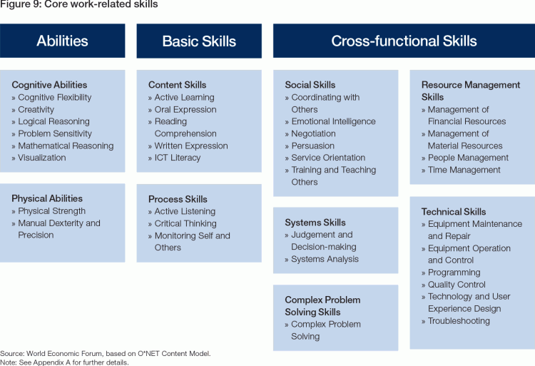

**National Science Foundation, Communicating Research to Public Audiences**

<https://nsf.gov/funding/pgm_summ.jsp?pims_id=5362>

This program has been archived.

**PROGRAM GUIDELINES**  
https://nsf.gov/images/hex-b6b6b6.gif  
Solicitation  [03-509](https://nsf.gov/publications/pub_summ.jsp?WT.z_pims_id=5362&ods_key=nsf03509)

**Important Information for Proposers**

A revised version of the NSF Proposal & Award Policies & Procedures Guide (PAPPG) (NSF 16-1), is effective for proposals submitted, or due, on or after January 25, 2016. Please be advised that, depending on the specified due date, the guidelines contained in NSF 16-1 may apply to proposals submitted in response to this funding opportunity.

**DUE DATES**

https://nsf.gov/images/hex-b6b6b6.gifArchived

**SYNOPSIS** https://nsf.gov/images/hex-b6b6b6.gif

Communicating Research to Public Audiences is a component of the Informal Science Education program (ISE) in the Division of Elementary, Secondary, and Informal Education.  ISE projects provide rich and stimulating contexts and experiences for individuals of all ages, interests, and backgrounds to increase their appreciation for, and understanding of, science, technology, engineering, and mathematics (STEM) in out-of-school settings.  Requests for up to $75,000 will be considered to support projects that communicate to public audiences the process and results of current research that is being supported by any NSF directorate through informal science education activities, such as media presentations, exhibits, or youth-based activities. The purpose of these efforts is to disseminate research results, research in progress, or research methods.

**Dear Colleague Letter: The Division of Electrical, Communications and Cyber Systems (ECCS), Directorate of Engineering (ENG) – Employment Opportunities for Communications, Circuits and Sensing Systems (CCSS) Program Director (Open Until Filled) (eccs16001) | NSF – National Science Foundation Date: November 24, 2015**

<http://www.nsf.gov/pubs/2016/eccs16001/eccs16001.txt?org=ENG>

…

Qualification requirements for the position are a Ph.D. or equivalent

professional experience in the relevant discipline in engineering or

science, plus six or more years of successful research, research

administration and/or managerial experience in academe, industry, or

government. The candidate must demonstrate vision and leadership to

identify and support long-term research and education that contributes

to the mission of the Division and NSF. NSF Program Directors have the

primary responsibility for carrying out the Agency's overall mission to

support innovative and merit-evaluated activities in fundamental

research and education that contribute to the nation's technological

strength, security, and welfare. This requires expertise in appropriate

disciplines to implement the proposal review and evaluation process for

the program, as well as strong skills in written and oral

communication, a commitment to high standards, considerable breadth of

interest and receptivity to new ideas, strong sense of fairness, good

judgment, and a high degree of personal integrity. The position

provides a challenging experience and an excellent opportunity to

encourage and support engineering research and education. The

individual will work with other Program Directors in formulating

research strategies, developing collaboration and cooperation across

the Foundation and among government, academe and industry, fostering

outreach to underrepresented groups, and providing leadership within

NSF and the research community.

**John Keith (2005). BCIT Survey Highlights Importance of Oral Communication Skills**

<http://www.johnkeithcommunications.com/listening/prof/BCITGradSurvey.html>

David Hamilton, an instructor in the Communication Department at BCIT, undertook a survey of both recent graduates of BCIT and companies who had considered BCIT graduates for employment.  The survey, which was conducted in the spring and early summer of 2005, polled 460 companies and more than a 1000 former BCIT students who had graduated between the years 2000 and 2004.  The results show the importance of English language skills for success in getting a job.

In an interim report on the survey results, David Hamilton wrote the following:

* "Over 90% of the employers said communication skills are at least as important as technical skills for newly hired employees in entry-level jobs. Only 13% said they were less important."
* "Over 96% of the employers said that communication skills are at least as important as technical skills for first-level managers."
* "Speaking and listening/understanding were rated slightly higher in importance than reading and writing."
* "Almost 50% of the employers said that they had turned down job applicants because of English communication problems. The main reason was an inability to speak clearly and to understand spoken English and to a lesser extent because of English errors on resumes."

Mr. Hamilton's report also included comments from the American National Association of Colleges and Employers and the Business Council of BC: "In the USA, the National Association of Colleges and Employers says in its Job Outlook 2005:  '… year after year, the number one skill employers look for is good communication skills: the ability to write and speak clearly.' ”

"In BC, the latest Biennial Skills and Attributes Survey of the Business Council of British Columbia, published in October 2004, emphasizes employers’ need for new hires with strong communication skills. In the list of the top-ten key skills that employers look for in all new hires, communication skills rank very highly, being chosen by about 90% of the employers. In this survey, writing was chosen by 93% of the respondents (giving it a ranking of 5 out of the top 10 skills), reading by 89% (ranked 7) and speaking/ listening by 89% (ranked 8)."

In the BC Business Council survey, interpersonal skills, which of course are built on a solid foundation of good oral communication ability, were rated the number one attribute that BC companies are looking for in hiring new workers.

  © John Keith 2005

**Engineering Communication Program**

<http://ecp.engineering.utoronto.ca/online-handbook/oral-communication/>

[Full Online Handbook](http://ecp.engineering.utoronto.ca/online-handbook/) | [Next Section](http://ecp.engineering.utoronto.ca/online-handbook/the-writing-process/)

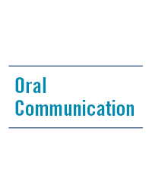

### In This Section

Information on how to effectively plan, practice, present and design visuals for an oral presentation.

[**Overview:**](http://ecp.engineering.utoronto.ca/online-handbook/oral-communication/overview/) An introduction to oral communication, including a sample speech outline.

[**Planning Your Talk:**](http://ecp.engineering.utoronto.ca/online-handbook/oral-communication/planning-your-talk/) Strategies for preparing your oral presentation.

[**Practicing Your Talk:**](http://ecp.engineering.utoronto.ca/online-handbook/oral-communication/practicing-your-talk/) Strategies and methods for rehearsing your presentation.

[**Performing Your Talk:**](http://ecp.engineering.utoronto.ca/online-handbook/oral-communication/performing-your-talk/) Tips you can use while giving your presentation.

[**Supporting Your Talk with Visuals:**](http://ecp.engineering.utoronto.ca/online-handbook/oral-communication/supporting-your-talk-with-visuals/) Tips for designing visuals and integrating visuals into your presentation.

**Judith Shaul Norback​‌, Georgia Institute of Technology (2013). Oral Communication Excellence for Engineers and Scientists. Synthesis Lectures on Professionalism and Career Advancement for Scientists and Engineers. July 2013, 137 pages, (doi:10.2200/S00510ED1V01Y201307PRO003)**

<http://www.morganclaypool.com/doi/abs/10.2200/S00510ED1V01Y201307PRO003>

**Abstract**

Many of us have implemented oral communication instruction in our design courses, lab courses, and other courses where students give presentations. Others have students give presentations without instruction on how to become a better presenter. Many of us, then, could use a concise book that guides us on what instruction on oral communication should include, based on input from executives from different settings. This instruction will help our students get jobs and make them more likely to move up the career ladder, especially in these hard economic times.

Oral Communication Excellence for Engineers and Scientists: Based on Executive Input is the tool we need. It is based on input from over 75 executives with engineering or science degrees, leading organizations that employ engineers and scientists. For the presentation chapter, the executives described what makes a “stellar presentation.” And for every other chapter, they gave input—on, for example, how to effectively communicate in meetings and in teams, how to excel at phone communication, how to communicate electronically to supplement oral communication, and how to meet the challenges of oral communication. They also provided tips on cross-cultural communication, listening, choosing the appropriate medium for a communication, elevator pitches, and posters; and using oral communication to network on the job.

Oral Communication Excellence for Engineers and Scientists includes exercises and activities for students and professionals, based on instruction that has improved Georgia Tech’s students’ presentation skills at a statistically significant level. Slides demonstrating best practices are included from Capstone Design students around the country.

Table of Contents: Introduction / Background Preparation / Presentation: Customizing to your Audience / Presentation: Telling your Story / Presentation: Displaying Key Information / Delivering the Presentation / Other Oral Communication Skills / Advanced Oral Communication Skills / References

**L. Versteele, Y. Berbers, E. Londers (2012). Written and oral communication across the engineering curriculum: An integrated learning trajectory.**

**Faculty of Engineering Science, KU Leuven, Belgium**

<http://www.sefi.be/conference-2012/Papers/Papers/048.pdf>

INTRODUCTION

Traditionally, most engineering education has been directed towards the development of

technical knowledge and skills. In recent times the literature about engineering education is

increasingly pointing to the need to reconsider these traditional engineering curricula

Highlighting the discrepancies between the skills emphasized in education and those

related to professional practice, several authors and organizations have insisted on the

enhancement of non-traditional engineering skills as written and oral communication,

team working, managerial and leadership as well as other personal skills. For instance, it is advocated that the communicative competencies of engineering students need to be improved, as such competencies have become pivotal in the engineering profession

In the present paper we aim to bridge the growing gap between current engineering curricula

and the demands from different circles outside higher education institutions. In particular,

article reports on an education project to revise our current engineering programme at the

Faculty of Engineering Science at KU Leuven and to integrate written and oral communication skills into our five-year programme of study.

To begin with, we provide an outline and critical analysis of the communication aspects in the

current programme of study. In the next section, we document our plans and efforts towards

developing a learning trajectory designed to strengthen written and oral communication skills

across the engineering curriculum. In this respect, we also describe the creation and intended

implementation of an extensive assessment rubric and didactic training sessions. Finally, we

will conclude and discuss and recommend future work.

**Murphy Donohue (2016). “Tackling the 'soft' skills gap: How you can prepare STEM students for employment,” Expert Perspective, July 29.**

<https://www.eab.com/research-and-insights/continuing-and-online-education-forum/expert-insights/2016/soft-skills-gap?WT.mc_id=Email|Daily+Briefing+Spotlight|EP|COE|Aug-08-2016||&elq_cid=2073911&x_id=003C000001yQi2MIAS>

# Tackling the 'soft' skills gap

## How you can prepare STEM students for employment

Expert Perspective|July 29, 2016

By Murphy Donohue

Currently, U.S. employers face a major gap in employee preparedness in “soft” skills. These baseline skills account for approximately one-third of skills requested in all U.S. job postings. In technical and STEM job postings specifically, the importance of “soft” skills remains critical; with over a quarter of all requested skills considered soft skills.

The constraints of rigid academic curricula in STEM programs leave little time to emphasize skills such as writing, communication, and organization. The soft skills gap impacts the short- and long-term employment prospects of graduates of highly technical STEM degree programs.

Through a clearer understanding of soft skills and the employer skills gap, COE units can better prepare students in highly technical degree programs to meet their long-term employment goals.

### How we define ‘soft’ skills

In 2015, researchers at [Burning Glass Technologies](https://www.eab.com/-/media/EAB/Research-and-Insights/COE/Burning-Glass/Human_Factor_Baseline_Skills_FINAL-4.pdf) provided a clearer definition of both soft and “hard” skills:

* **Hard skills** most commonly refer to highly technical tasks that are unique to an occupation or industry.
* **Soft skills** refer to more baseline responsibilities, which can include communication and writing in addition to broad technical skills (e.g., basic math). Due to STEM curricular constraints, these skills are commonly thought of as unteachable.

For employers, the greater struggle is to identify candidates that possess both hard and soft skills. As the researchers at Burning Glass found, employers looking to fill upper-level management STEM positions often find that candidates lack basic word processing skills, such as Microsoft Excel and Microsoft Word.

**Example of Soft and Hard Skills in Engineering**

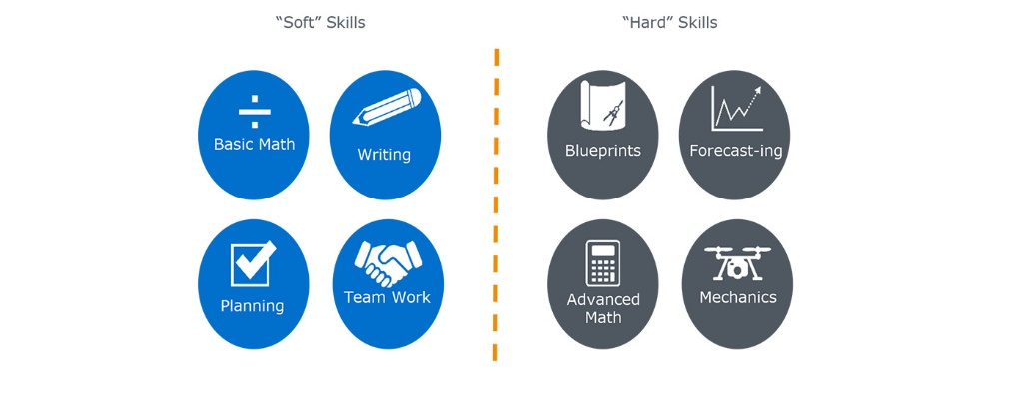

### Defining the gap

[Employers](https://www.luminafoundation.org/files/publications/Closing_the_skills_gap.pdf) are increasingly concerned about STEM students’ lack of preparedness in soft skills, specifically in planning, communication, and critical thinking. This lack is what is referred to in the “employer skills gap.” Burning Glass determined the size of the employer skills gap by determining the relative importance of a skill in a given occupation—using skill rankings in [O*NET job profiles](https://www.onetonline.org/find/)—and the number of job postings that include that skill. Skills with relatively low rankings in O*NET job profiles that appear most frequently in actual job postings fall into the largest skills gaps.

##### Related

[**How to help more students become "T-shaped professionals"**](http://ns.advisory.com/DesignThinkingWP?WT.ac=Callout%C2%A0_COE_CG+-+Whitepaper___x_Q316_Eloqua-Daily+Briefing_)

Previous EAB research on ["T-shaped professionals"](https://www.eab.com/research-and-insights/continuing-and-online-education-forum/studies/2014/t-shaped-professionals) suggests it is important to confer both soft and hard skills in program curricula to ensure the development of well-rounded professionals. Students develop soft and collaborative skills as part of the T-top and highly-demanded technical skills for the T-stem. Students with a mix of T-top and T-stem skills face the most promising opportunities for short and long-term employment.

### You May Also Like

##### White Paper

## [Hyper-Stackable Emerging Careers](https://www.eab.com/research-and-insights/continuing-and-online-education-forum/studies/2014/hyperstackable-emerging-careers)

##### Study

## [Designing Programs for the Millenial Workforce](https://www.eab.com/research-and-insights/continuing-and-online-education-forum/studies/2015/designing-programs-for-the-millennial-workforce)

##### Expert Perspective

## [How COE units can help close the skills gap](https://www.eab.com/research-and-insights/continuing-and-online-education-forum/expert-insights/2016/t-shaped-professionals)

Truthfully, many employers do not include all necessary skills in a job posting. Instead many employers assume that qualified candidates already possess the technical skills needed for the job (e.g., mathematics in mechanical engineering).

The largest skills gap is found in high growth skills (i.e., skills with high demand growth between 2014 and 2015). Of the 20 most frequently sought soft skills for STEM professionals, the following experienced the greatest growth in demand between 2014 and 2015:

* Creativity
* Team work/collaboration
* Quality assurance
* Detail-orientated
* Building effective relationships

**Fastest Growing Soft Skills Sought by STEM Employers**

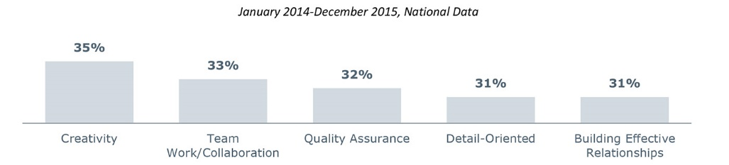

In addition, employers overwhelmingly seek out with employees with communication skills, as it is listed in over 37% of STEM job postings. Moreover, across all occupational families, employers report that writing skills remain the largest skills gap.

**Most Commonly Requested Soft Skills by Occupational Family**

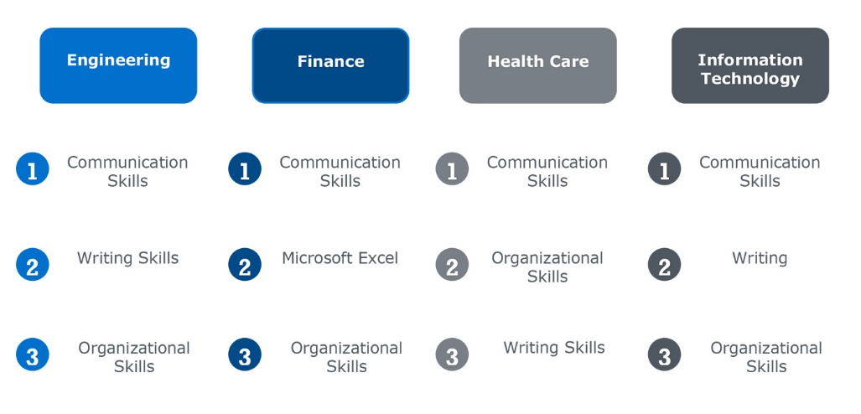

### Plugging the soft skills gap

COE units play a pivotal role in helping to close the skills gap between students and potential employers. Below we outline the three most frequently requested soft skills, and how you can design COE programs to teach students these skills.

1. Communication skills

A foundation of communication and interpersonal skills is vital to professional success in the workplace, since interpersonal skills influence relationships and workflow with both colleagues and clientele.

COE units can help develop their students’ communication skills through group work and oral presentations. Integrate group projects into classwork to develop those interpersonal skills fundamental to building and maintaining workplace relationships. Group projects also foster collaboration, delegation of workloads, and responsiveness to peer review and criticism.

Oral presentations allow students to develop the communication skills necessary to work with customers. Consider the addition of oral presentations to non-experts into coursework to provide students with experience in public speaking and the use of nontechnical terms.

**Techniques to Confer Communication Skills**

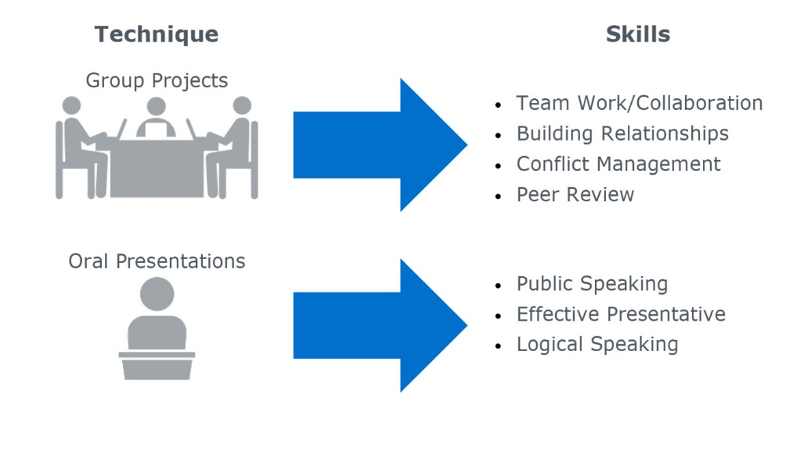

2. Leadership skills

Employers express a growing interest in candidates who possess strong leadership skills, but feel the skill is not reflected in students’ professional and educational experiences. For example, engineering employers struggle to find employees that have project management skills. In health care, employers most often find that employees lack sufficient supervisory skills.

Apprenticeships typically last longer than internships, include the conferral of specific industry skills, and often include formal pathways to employment.

COE units can develop internship and apprenticeship programs with top employers in STEM industries to provide students with opportunities to develop stronger leadership skills. Previous [EAB research](https://www.eab.com/research-and-insights/continuing-and-online-education-forum/expert-insights/2016/t-shaped-professionals) also suggests that internship opportunities allow students to experience the workplace firsthand and develop leadership skills through the emulation of the industry professionals for whom they intern.

In a survey of U.S. employers, The Economist and the Lumina Foundation [found](https://www.luminafoundation.org/files/publications/Closing_the_skills_gap.pdf) that almost 80% of respondents expressed a willingness to offer internships, and half of those surveyed also expressed an interest in apprenticeships.

**Techniques to Confer Leadership Skills**

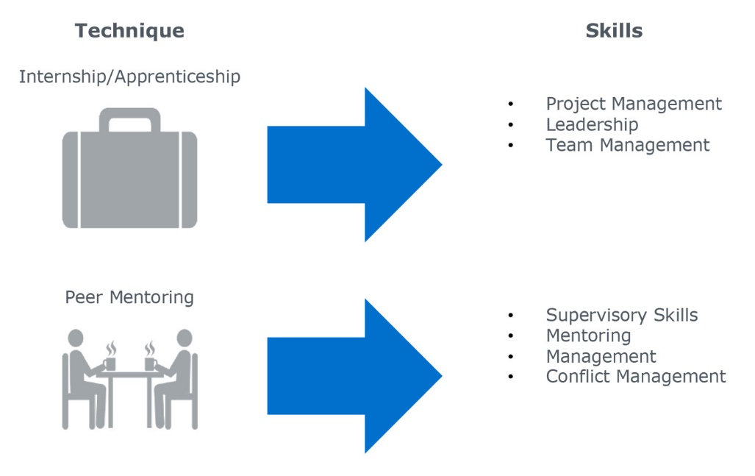

3. Organizational skills

Basic organizational skills are vital to professional success across industries. Organization, time management, and effective planning allow professionals to more effectively manage workflow and communicate with supervisors about deadlines. In addition, organizational skills also allow STEM professionals to manage data and complete tasks expediently.

COE units should provide students with opportunities to develop organizational skills through extended research projects. Semester or year-long research projects provide students with opportunities to learn how to manage time, plan projects, and work within deadlines.

**Techniques to Confer Organizational Skills**

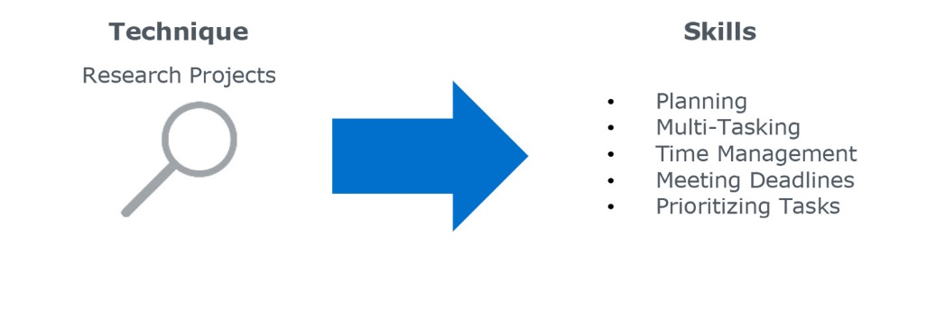

### Pinpoint the most in-demand jobs in your state