**Attachment Three: Oral communication a key factor in career success**

**The Top 10 Skills Employers Most Want in 2015 Graduates**

<http://www.forbes.com/sites/susanadams/2014/11/12/the-10-skills-employers-most-want-in-2015-graduates/#21044a2419f6>

The National Association of Colleges and Employers (NACE) a Bethlehem, PA non-profit group that links college career placement offices with employers, ran a survey from mid-August through early October where it asked hiring managers what skills they plan to prioritize when they recruit from the class of 2015 at colleges and graduate schools. Though the survey sample is small—NACE collected responses from just 260 employers—the wisdom is sound. New and recent grads should pay attention. (Most of the respondents were large companies like Chevron, IBM and Seagate Technology.)

College majors and graduate degrees also matter. The three degrees most in demand for the class of 2015 are business, engineering, and computer & information sciences. But cutting across all majors and degrees, employers want new hires who can work well on teams, and who are decisive problem-solvers.

Here are the 10 skills employers say they seek, in order of importance. ….

1. Ability to work in a team structure

2. Ability to make decisions and solve problems (tie)

3. Ability to communicate verbally with people inside and outside an organization

4. Ability to plan, organize and prioritize work

5. Ability to obtain and process information

6. Ability to analyze quantitative data

7. Technical knowledge related to the job

8. Proficiency with computer software programs

9. Ability to create and/or edit written reports

10. Ability to sell and influence others

The good news for grads: No matter what you have studied in school, whether anthropology or French or computer science, you will have had to learn the top five skills on the list. The trick is to demonstrate that you have those skills through your cover letter, résumé and interview. Think about class projects where you have been a team member or leader and jobs where you have had to plan and prioritize. Describe those skills specifically in your résumé and cover letter and in your job interview.

**AAC&U (2014). It Takes More than a Major: Employer Priorities for College Learning and Student Success: Overview and Key Findings: A 2013 National Survey of Business and Non Profit Leaders**

<http://www.aacu.org/leap/presidentstrust/compact/2013SurveySummary>

<http://aacu.org/sites/default/files/files/LEAP/KeyFindingsfrom2013SurveyofEmployers.pdf>

<https://www.aacu.org/sites/default/files/files/LEAP/2013_EmployerSurvey.pdf>

**Cross-Cutting Capacities vs. Choice of Undergraduate Major**

* Nearly all those surveyed (93 percent) say that “a demonstrated capacity to **think critically, communicate clearly, and solve complex problems** is **more important than [a candidate’s] undergraduate major.”**
* More than 9 in 10 of those surveyed say it is important that those they hire demonstrate **ethical judgment and integrity; intercultural skills; and the capacity for continued new learning.**
* More than 75% of employers say they want *more emphasis* on 5 key areas including: **critical thinking, complex problem-solving, written and oral communication, and applied knowledge in real-world settings.**
* Employers endorse several educational practices as potentially helpful in preparing college students for workplace success.  These include practices that require students to a) conduct **research and use evidence-based analysis**; b) gain in-depth knowledge in the major and **analytic, problem solving and communication skills**; and c) apply their learning in **real-world settings.**

*Key Findings from 2013 Survey of Employers*



* **Innovation a Priority:** 95% of employers say they give hiring preference to college graduates with skills that enable them to contribute to innovation in the workplace.
* **It Takes More than a Major:** 93% of employers say that a demonstrated capacity to think critically, communicate clearly, and solve complex problems is more important than a candidate’s undergraduate major. More than 75% want higher education to place more emphasis on critical thinking, complex problem solving, written and oral communication, and applied knowledge.
* **Broad Learning is Expected:** 80% of employers agree that, regardless of their major, all college students should acquire broad knowledge in the liberal arts and sciences.
* **Students Need Liberal and Applied Learning:** Employers strongly endorse educational practices that involve students in active, effortful work—practices including collaborative problem solving, research, internships, senior projects, and community engagements.
* **E-Portfolios Would Add Value:** 83% of employers say an electronic portfolio would be useful to indicate that job applicants have the knowledge and skills they need to succeed.

***Employer Priorities and Consensus on College Learning Outcomes***

**Knowledge of Human Cultures and the Physical and Natural World**

* + Broad knowledge in the liberal arts and sciences 80% n
  + Global issues and knowledge about societies and cultures

outside the US 78% n

* + Knowledge about science and technology 56% v

**Intellectual and Practical Skills**

* + Critical thinking and analytic reasoning 82% v
  + Complex problem solving 81% v
  + Written and oral communication 80% v
  + Information literacy 72% v
  + Innovation and creativity 71% v
  + Teamwork skills in diverse groups 67% v
  + Quantitative reasoning 55% v

**Personal and Social Responsibility**

* + Problem solving in diverse settings 91% n
  + Ethical issues/public debates important in their field 87% n
  + Civic knowledge, skills, and judgment essential for contributing

to the community and to our democratic society 82% n

* + Ethical decision making 64% v

**Integrative and Applied Learning**

* + Direct experiences with community problem solving 86% n
  + Applied knowledge in real-world settings 78% v

**NOTES:**

n indicates percentage of employers who “strongly agree” or “somewhat agree” that, “regardless of a student’s chosen field of study,” every student should attain this area of knowledge or skill. v indicates percentage of employers who say they want colleges/universities to “place more emphasis” on this area of knowledge/skill. **Source:** Hart Research Associates. *It Takes More Than a Major: Employer Priorities for College Learning and Student Success* (Washington, DC: AAC&U, 2013), [www.aacu.org/leap/public_](http://www.aacu.org/leap/public_) opinion_research.cfm

**Association of American Colleges & Universities/ Hart Research Associates,**

**“Falling Short? College Learning and Career Success”**

<https://www.aacu.org/sites/default/files/files/LEAP/2015employerstudentsurvey.pdf>

The majority of employers continue to say that possessing both field-specific knowledge and a broad range of knowledge and skills is important for recent college graduates to achieve long-term career success. Very few indicate that acquiring knowledge and skills mainly for a specific field or position is the best path for long-term success. Notably, college students recognize the importance of having both breadth and depth of skills and knowledge for their workplace success.

Echoing findings from previous Hart Research employer surveys, employers say that when hiring, they place the greatest value on demonstrated proficiency in skills and knowledge that cut across all majors. The learning outcomes they rate as most important include written and oral communication skills, teamwork skills, ethical decision-making, critical thinking, and the ability to apply knowledge in real-world settings. Indeed, most employers say that these cross-cutting skills are more important to an individual’s success at their company than his or her undergraduate major.

However, employers feel that today’s college graduates are not particularly well prepared to achieve the learning outcomes that they view as important. This critique applies to all of the 17 learning outcomes tested, including the cross-cutting skills that employers highly value.

Employers value the ability to apply learning in real-world settings and broadly endorse an emphasis on applied learning experiences in college today.

* 88% think that it is important for colleges and universities to ensure that all students are prepared with the skills and knowledge needed to complete an applied learning project.
* 73% think that requiring college students to complete a significant applied learning project before graduation would improve the quality of their preparation for careers.
* 60% think that all students should be expected to complete a significant applied learning project before graduating.
* Large majorities say they are more likely to consider a job candidate who has participated in an internship, a senior project, a collaborative research project, a field-based project in a diverse community setting with people from different backgrounds, or a community-based project.

College students are closely aligned with employers on the importance of key learning outcomes, and, like employers, they believe that applied learning experiences are an important preparation for career success.

College students are notably out of sync with employers in their perception of their preparedness on a wide range of skills and knowledge areas, however. Students express much greater confidence in their level of preparedness in all areas than employers indicate they see demonstrated.

**Appendix: World Economic Forum, Top 10 Skills**

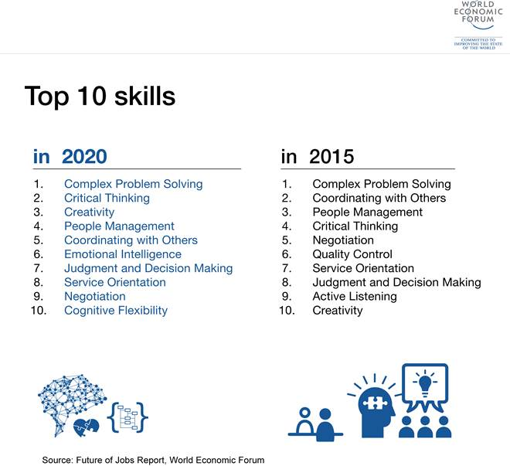

**http://www3.weforum.org/docs/WEF_Future_of_Jobs.pdf**

**--**

**Appendix: NACE (2016). Employers: Verbal Communication Most Important Candidate Skill.**

**Spotlight for Career Services Professionals February 24, 2016**

<http://www.naceweb.org/s02242016/verbal-communication-important-job-candidate-skill.aspx>

When asked to assess candidate skills/qualities, employers rated verbal communication skills the most important, according to NACE's *Job Outlook 2016* report.

Employers rated verbal communication skills (4.63 on a five-point scale) highest this year, above teamwork (4.62) and the ability to make decisions and solve problems (4.49), the two skills that tied for the top spot last year.

The remainder of the list has not changed at all in terms of order compared to last year. The one difference this year is that more of the skills/qualities were rated just below 4.0 ("very important") than last year. Just two skills/qualities were rated below 4.0 last year—ability to create and/or edit written reports and the ability to sell or influence others.

While those two remain at the bottom of this year's list, they are joined by technical knowledge related to the job and proficiency with computer software programs with ratings under 4.0.

The *Job Outlook 2016* survey was conducted from August 5, 2015, through September 13, 2015, among NACE employer members. A total of 201 NACE employer members participated in the survey—a 20.1 percent response rate.

[NACE members can access the *Job Outlook 2016* report through MyNACE.](http://www.naceweb.org/job-outlook/index.aspx)

Results of the annual *Job Outlook* survey—especially employer insight into the skills they seek in new college graduate job candidates—served as one of the foundation pieces upon which NACE constructed its [Career Readiness Competencies](http://www.naceweb.org/knowledge/career-readiness-competencies.aspx).

**Employers: Verbal Communication Most Important Candidate Skill (continued)**

**Figure 1: Employers rate the importance of candidate skills/qualities**

|  |  |
| --- | --- |
| **Skill/Quality** | **Weighted Average Rating** |
| Ability to verbally communicate with persons inside and outside the organization | 4.63 |
| Ability to work in a team structure | 4.62 |
| Ability to make decisions and solve problems | 4.49 |
| Ability to plan, organize and prioritize work | 4.41 |
| Ability to obtain and process information | 4.34 |
| Ability to analyze quantitative data | 4.21 |
| Technical knowledge related to the job | 3.99 |
| Proficiency with computer software programs | 3.86 |
| Ability to create and/or edit written reports | 3.60 |
| Ability to sell or influence others | 3.55 |

Source: *Job Outlook 2016*, National Association of Colleges and Employers  
*5-point scale, where 1=Not at all important; 2=Not very important; 3=Somewhat important; 4=Very important; and 5=Extremely important

- See more at: <http://www.naceweb.org/s02242016/verbal-communication-important-job-candidate-skill.aspx#sthash.P2eVbide.dpuf>